**Project Design Phase-II**

**Data Flow Diagram & User Stories**

|  |  |
| --- | --- |
| Date | 31 January 2025 |
| Team ID | LTVIP2025TMID36223 |
| Project Name | GRAINPALETTE |
| Maximum Marks | 4 Marks |

**Data Flow Diagrams:**

A Data Flow Diagram (DFD) is a traditional visual representation of the information flows within a system. A neat and clear DFD can depict the right amount of the system requirement graphically. It shows how data enters and leaves the system, what changes the information, and where data is stored.

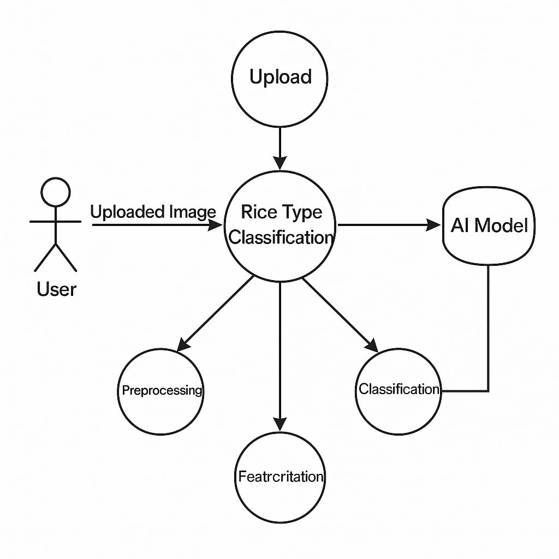

**User Stories**

Use the below template to list all the user stories for the product.

| **User Type** | **Functional Requirement (Epic)** | **User Story Number** | **User Story / Task** | **Acceptance Criteria** | **Priority** | **Release** |
| --- | --- | --- | --- | --- | --- | --- |
| Customer (Mobile user) | Registration | USN-1 | As a user, I can register by entering email, password, and confirming password. | I can access my account/dashboard | High | Sprint-1 |
|  |  | USN-2 | As a user, I will receive a confirmation email after registration. | I can receive confirmation email & click confirm | High | Sprint-1 |
|  |  | USN-3 | As a user, I can register via Facebook. | I can register & access the dashboard using Facebook login | Low | Sprint-2 |
|  |  | USN-4 | As a user, I can register via Gmail. | I can register using Gmail | Medium | Sprint-1 |
|  | Login | USN-5 | As a user, I can log in with email and password. | Login successful; redirected to dashboard | High | Sprint-1 |
|  | Dashboard | USN-6 | As a user, I can upload a rice image for classification. | I can see prediction and image preview after upload | High | Sprint-1 |
|  | Dashboard | USN-7 | As a user, I can view the predicted rice type and try another image. | I can click "Try Another" and re-upload | Medium | Sprint-1 |
|  | Dashboard | USN-8 | As a user, I can view basic information about the app. | I can scroll to the About section | Low | Sprint-2 |